**3.Hello World RESTful Web Service**

**HelloController.java**

package com.cognizant.springlearn.controller;

import org.slf4j.Logger;

import org.slf4j.LoggerFactory;

import org.springframework.web.bind.annotation.GetMapping;

import org.springframework.web.bind.annotation.RestController;

@RestController

public class HelloController {

private static final Logger *LOGGER* = LoggerFactory.*getLogger*(HelloController.class);

@GetMapping("/hello")

public String sayHello() {

*LOGGER*.debug("START sayHello()");

String message = "Hello World!!";

*LOGGER*.debug("END sayHello()");

return message;

}

}

**SpringLearnApplication.java**

**package** com.cognizant.spring_learn;

**import** org.springframework.boot.SpringApplication;

**import** org.springframework.boot.autoconfigure.SpringBootApplication;

**import** org.springframework.context.annotation.ComponentScan;

@SpringBootApplication

@ComponentScan("com.cognizant.springlearn.controller")

**public** **class** SpringLearnApplication {

**public** **static** **void** main(String[] args) {

SpringApplication.*run*(SpringLearnApplication.**class**, args); }}

**application.properties**

spring.application.name=spring-learn

server.port=9099

**Output:**

* **Chrome:**

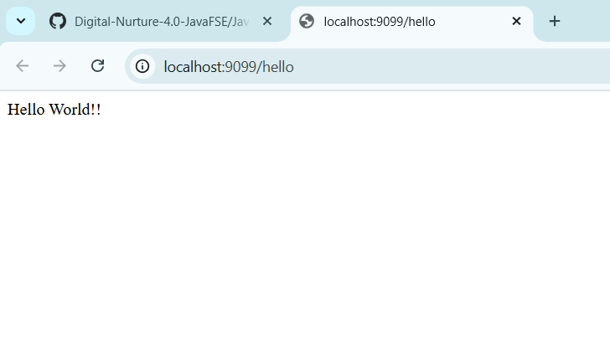

* Postman:

